Name___________________________________

Quick Quiz

**Unit Rate 6**

Identify the unit rate:

1. 5 pencils for 11 dollars 2. $y=x$

**$_________ per pencil unit rate =_________**

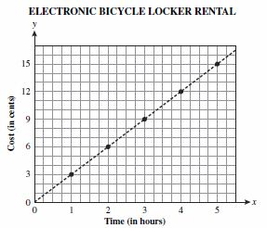

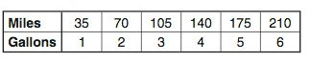3. 4.  **$________**

**per hour**

**_________ miles per gallon**

____________________________________________________________________________

Corrections

**Unit Rate 6**

Identify the unit rate:

1. 5 pencils for 11 dollars 2.

**$_________ per pencil unit rate =_________**



3. 4.  **$________**

**per hour**

**_________ miles per gallon**